Cards for students to discuss: For Matter Association (7 cards),
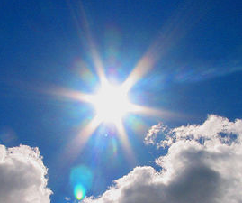 | 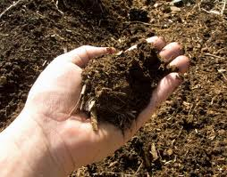 | Oxygen (O₂) | Carbon dioxide (CO₂)
Sunlight | Soil | In Air | In Air
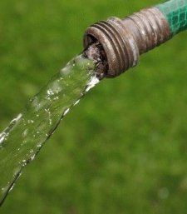 | 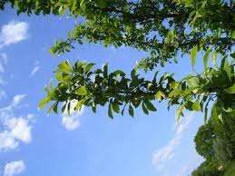 | 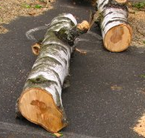 | 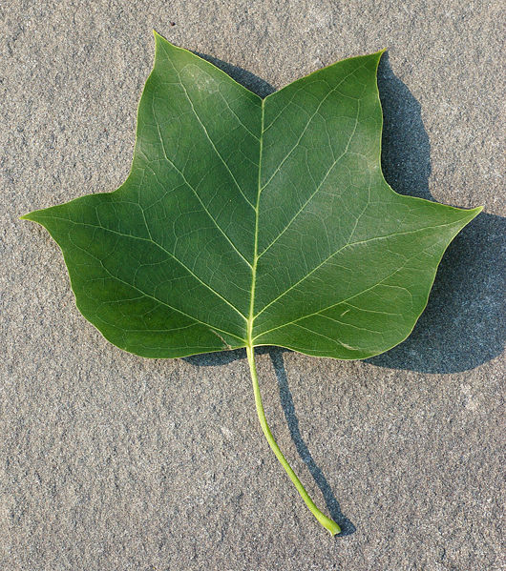
Water (H₂O) | Living Branches | Dead Wood | A Leaf
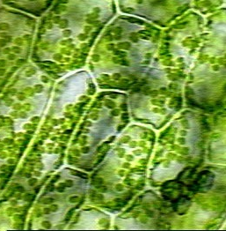 | 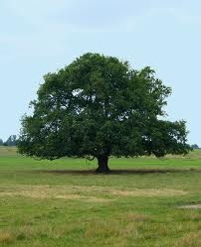 |  | 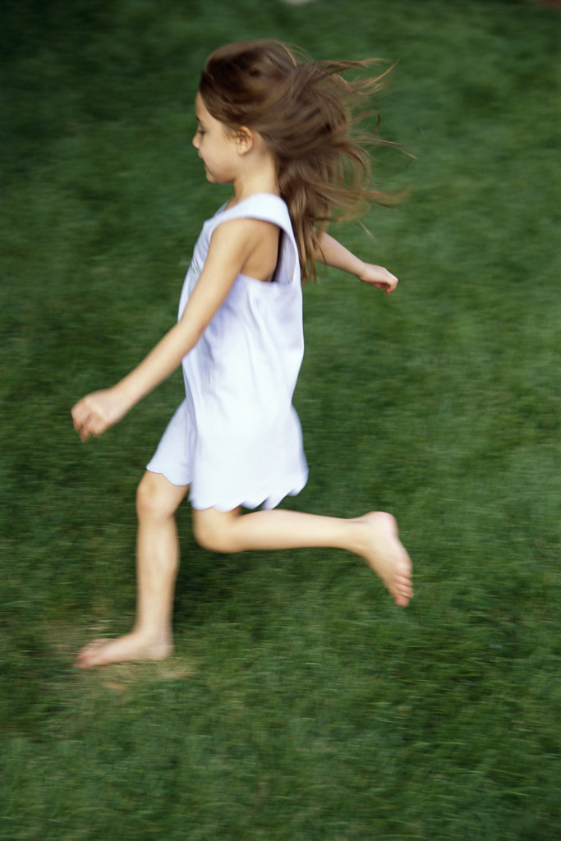
Close-up of a leaf | Tree Growth | Baby girl growth | Girl Running
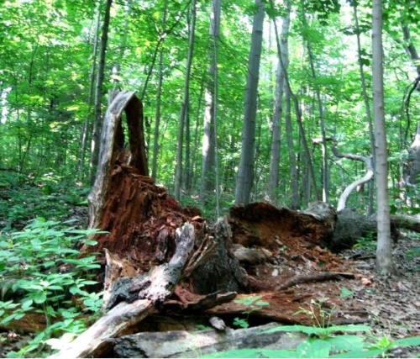 | 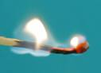 | 
Tree Decaying | Flame burning | Car running

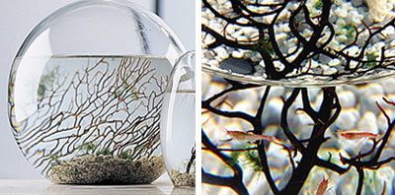  Tell the Student: NASA scientists invented the EcoSphere – inside a completely sealed glass container, (there is no opening at the top of the jar!) there are air, water, gravel, (the branch-like thing is just for show) and three living things – algae, shrimp, and bacteria. The shrimp are orange and the algae are green like a plant, you can’t see the bacteria.) Usually, these three living things can stay alive in the container for two or three years until the shrimp become too old to live. The picture above shows an EcoSphere and it’s inside parts. The EcoSphere is a closed ecosystem and has no exchange of matter with the outside environment. | 

